Model Picture |  | 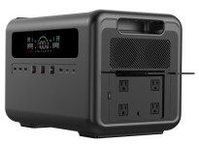  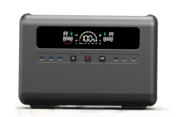  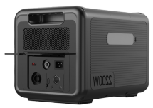
 |  | Q2000 | Q1500
Rated AC Output |  | 2200W | 1500W
Rated Capacity |  | 2016Wh | 1440Wh
Standard Capacity |  | 48V/42Ah or  3.2V/630000mAh | 48V/30Ah or  3.2V/450000mAh
Bettery Type |  | LiFePO4
UPS |  | YES
Charging Temperature Range |  | 0℃~40℃
Charge  Way | AC Input | 1200W
 | DC Input | NO
 | Car Charge | 12V/10A(120W)
 | Solar Charge (MPPT) | 800W
USB Output | USB-Type-C | PD 100W*2
 | USB-A | QC3.0*4(72W max)
DC port Output |  | 12V/5A*2(120W)
Cigarret Lighter Output |  | 12V/10A(120W)
LED Light |  | SOS,Flshlingt(8W)
AC Output | Output waveform | Pure Sine Wave
 | Output voltage | 110V/220V
 | Output frequency | 50/60Hz
 | AC continuous output | 2200W | 1500W
 | Peak AC output | 4400W | 3000W
 | Maximum device power that can be worked | 4400W | 3000W
Discharging Temperature Range |  | -10~40℃
Authentication |  | UL,FCC,CE,ROSH,PSE,UN38.3,SAA,UKCA
Product Size |  | 410*290*290mm
Weight |  | about22kg | about18kg
Warrantly |  | 18 months
Accessories |  | portable power supply 1*User Manual color box packaging 1*MC4 charging cable 1*vehicle charging cable  1*AC cable | portable power supply 1*User Manual color box packaging 1*MC4 charging cable 1*vehicle charging cable  1*AC cable

